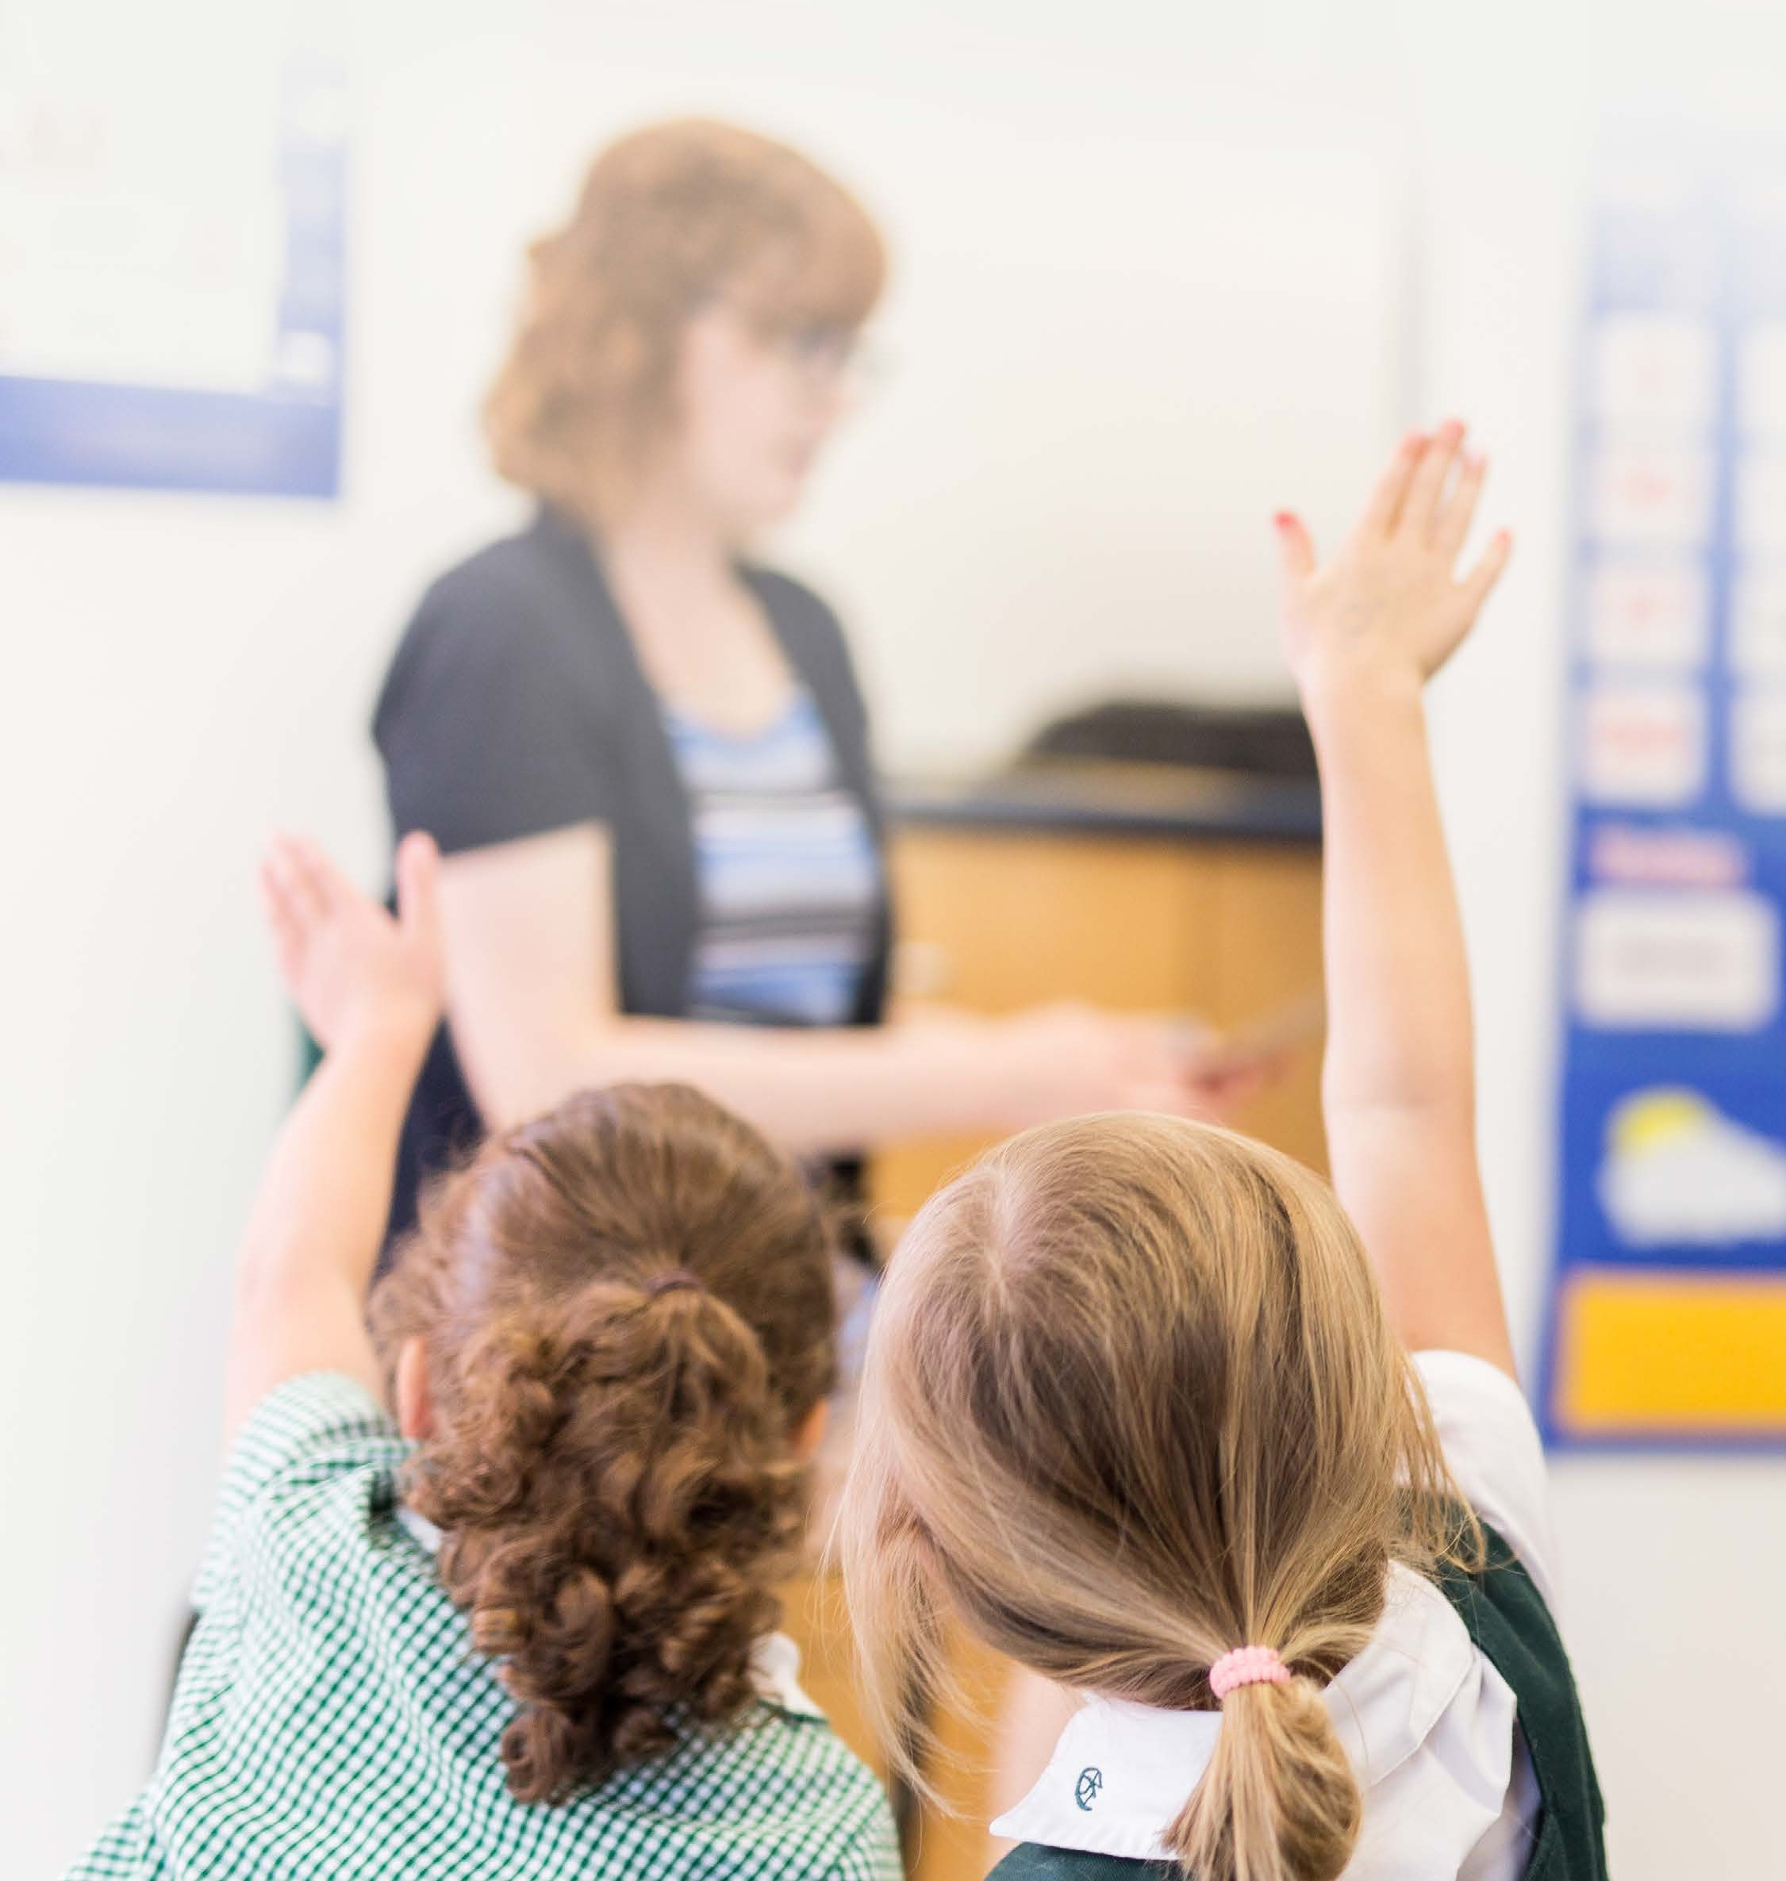
Top Five Tips For
KINDERGARTEN READINESS

Encouraging Emerging Literacy & Numeracy
- Has your child shown interest in or tried to read familiar signs and labels she has encountered? Recognizing environmental print is an important first step on the journey to literacy. Drawing your child’s attention to road signs, labels on packaging and signs on storefronts will help your child learn that all text carries meaning.
- Trips to the library and daily story times are simple activities that will help your child develop a love of books and reading.
- Exploring letters using your child’s first name is a great way to introduce the alphabet and encourage your child’s letter recognition. Teaching your child to write at least the first letter of her name is a good starting point to prepare your child for Kindergarten.
- Playing simple counting and number games will help your child develop her emerging number sense. For example, counting the stairs as you walk up or down together, count the number of fruits or vegetables in your grocery cart while shopping, discuss the numbers that you see around you on price tags, checkout aisles and other signs.

Fostering Independence
- Kindergarten is a time for children to develop their spirit of independence.
- Purchasing shoes (with Velcro), boots and jackets that your child can put on by herself will allow her to exercise her independence.
- Food containers that she can open herself will allow her to feel successful during snack and meal times.
- Encourage your child to come up with solutions to her own problems. With some thinking and reflection, “I can’t fasten my zipper on my own” (a problem) can become “I need some help to fasten my zipper please” (a solution).

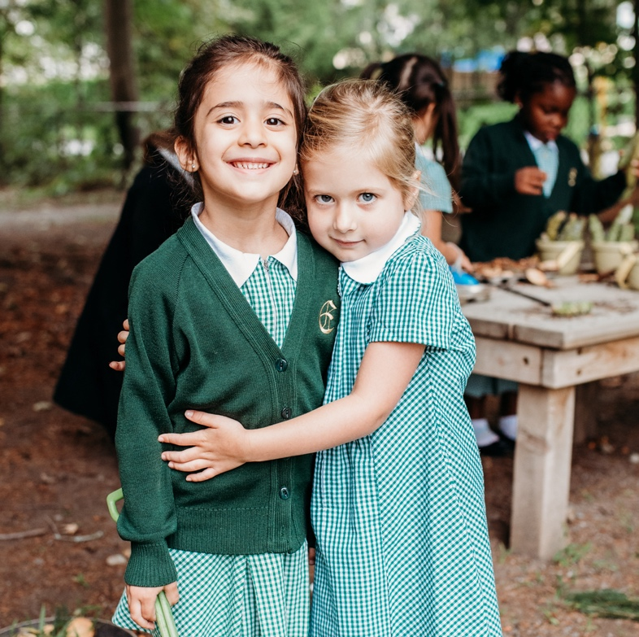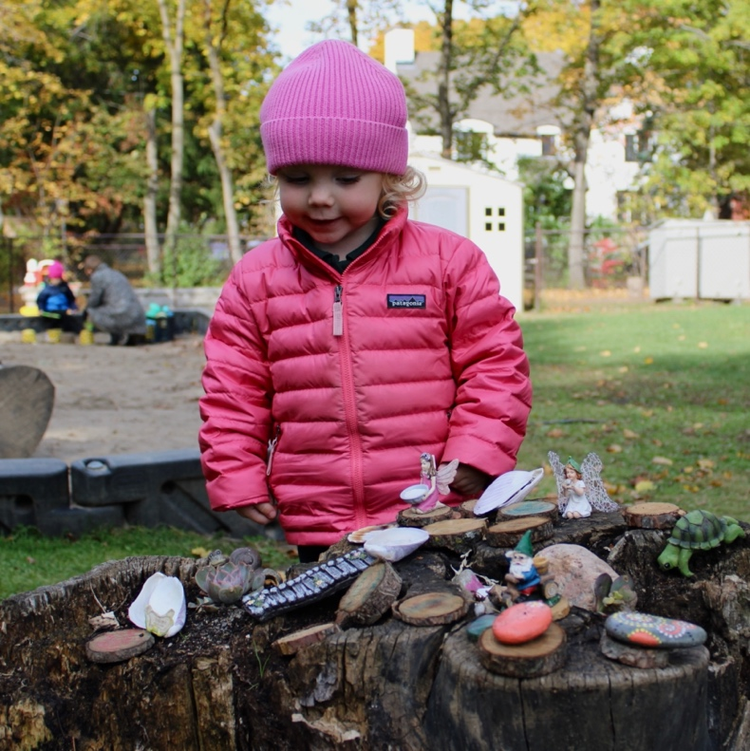

Developing Social Skills
- Play groups, story times at libraries, instructional classes (music, gymnastics, dance) provide many opportunities for your daughter to interact with other children. This will help her develop the social skills to navigate the kindergarten classroom successfully and form lasting, happy friendships with her classmates.
- Separation anxiety – separations become easier the more you practice them. Having your child attend unparented classes (swimming etc.) is great opportunity for them to practice saying goodbye and learning that mommies and daddies always come back.

Fine & Gross Motor Skills
- It’s okay to make a mess! Play dough, painting, safety scissors and colourful paper, sensory bins full of sand, water, beans, or shaving cream are all messy, but are rich sites for your child to hone her developing fine motor skills. Strong fine motor skills will help your child develop her written expression through drawing and printing.
- When children are allowed to take age-appropriate risks, they develop confidence in their physical literacy. Visits to local playgrounds, opportunities to play and explore outside, as well as run, jump and climb will help your child develop
her gross motor skills and coordination. For children that respond better to more structured activities or need some encouragement, gymnastics or dance/music and movement classes can be beneficial, as well.

Sleep
- Getting a kindergartner to go to bed at a reasonable and consistent time each night may take some practice and a good time to start practicing bedtime is the summer before kindergarten.
- Development and growth occurs in children when they sleep. Lack of sleep can make it difficult for your child to concentrate, handle social situations, follow directions and adapt to changes in routine.
- Junior Kindergarten-aged children need 10-12 hours of sleep, including a nap for some children.

What do Kindergarten-aged children need?
  - To be given time for unstructured play
  - To move their bodies and to practice times of stillness
  - To be listened to and spoken to using rich vocabulary
  - To have their questions taken seriously and to be taught to use various resources to answer them
  - To be trusted as they develop the self-confidence to take risks
  - To be nurtured AND to be encouraged to be independent in areas in which they are capable

How does Elmwood Kindergarten meet these needs?
  - Small class size that allows teachers to get to know each child and her interests
  - Primary Years Programme of the International Baccalaureate: Curriculum that is student-centred, inquiry- driven and emphasizes the development of each learner’s character through the learner profile
  - Reggio-Emilia inspired classroom environment that is purposefully designed with materials carefully selected to spark inquiry and to provoke meaningful questions tied to each unit of inquiry
  - Play and movement is highly prioritized through indoor learning activities and outdoor exploration

Want to learn more? Contact Elmwood Admissions to set up a private tour.
Elise Aylen, Director of Admissions
admissions@elmwood.ca • (613) 744-7783 | elmwood.ca

